Certificate for windows install

C:\CSSPTools\src\assets\CharlesLeBlanc_CSSPDesktop.cer

**NOTE:** New software installed on Windows 10 now requires a trusted certificate from the person/company wanting to install their application.

Usually, companies would get these trusted certificates from certificate providers (specialized companies responsible to verify your identity). Like opening an account at a bank. To save 100 $ / year all users will have to manually install a temporary certificate (CharlesLeBlanc_CSSPDesktop.cer)… if you trust me.

Before the users can install the CSSPDesktop application on their computers they will have to install a certificate (CharlesLeBlanc_CSSPDesktop.cer. Here is how.

**Installing a Certificate:**

1. Copy the attached file CharlesLeBlanc_CSSPDesktop.docx on your desktop
2. Rename it to “CharlesLeBlanc_CSSPDesktop.cer” or “anything_else.cer”. (extension has to be .cer)
3. Double click on the CharlesLeBlanc_CSSPDesktop.cer file
   1. 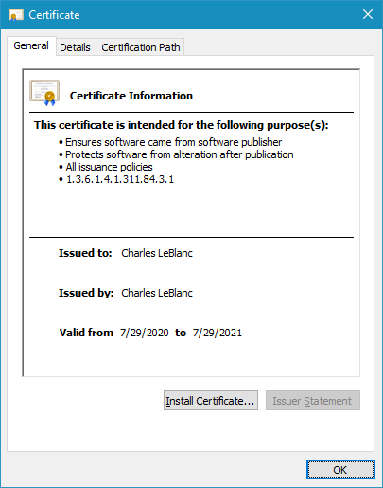
4. Click on the Install Certificate button
   1. 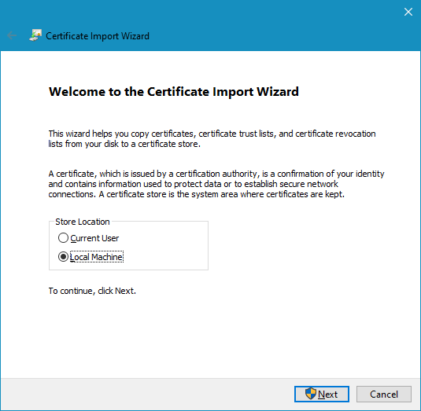
5. Select Local Machine and click Next
   1. You might be asked to give access to the application via a User Account Control dialog box
   2. Click Yes
   3. 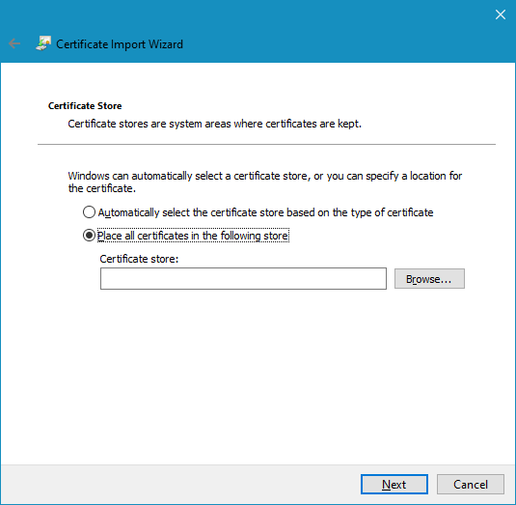
6. Select Place all certificates in the following store
7. Click Browse…
   1. 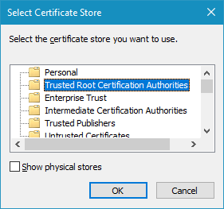
8. Select Trusted Root Certification Authorities … and click OK
9. Click Next
   1. 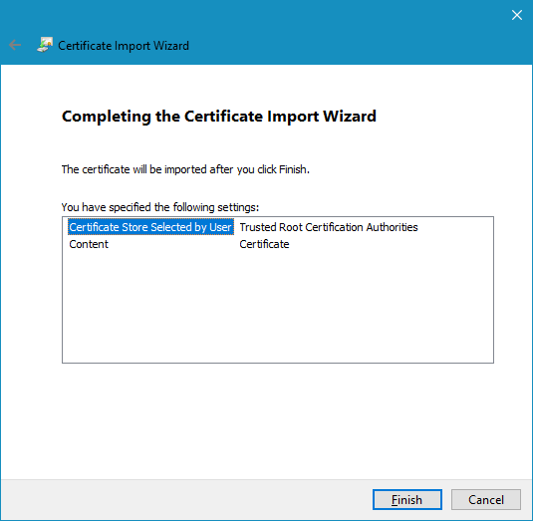
10. Click Finish
    1. 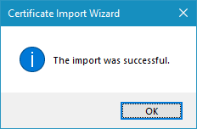
11. Click OK

**Uninstalling the Certificate:**

1. Press the windows button or start writing Certificate on the bottom left search panel
2. You should see “Manage User Certificates”. Clicking on it should open.
   1. 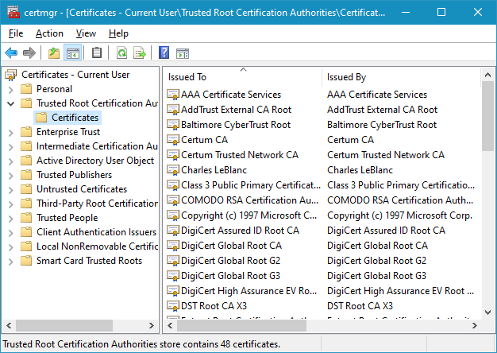
3. Go under “Trusted Root Certification Authorities” -- > “Certificates”
4. Find “Charles LeBlanc” and click on it. Then you can press “Delete” or “Right Mouse click” and Delete.
   1. 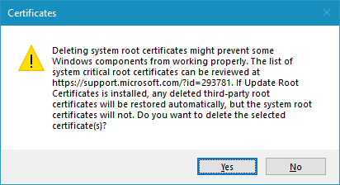
5. Click Yes